Cuarta sesión remota 2019-2020

Iratxe Campo Larrinaga

Asier Fernández de Lecea

* **Máquina de estados**

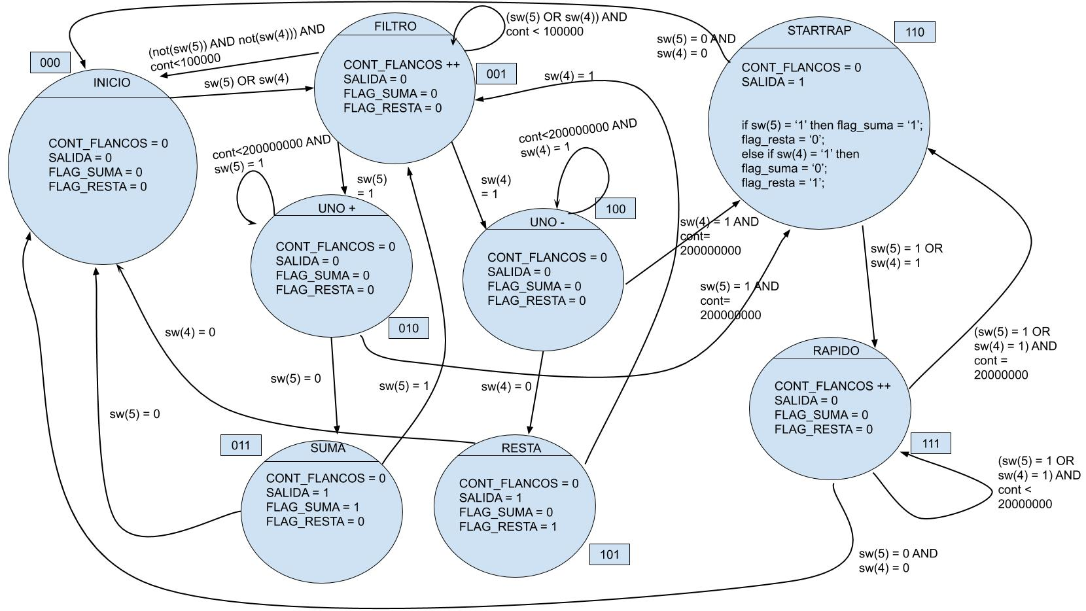

* **Diseño y prueba del nuevo autómata de detección de pulso para velocidad rápida.**

Hecho.

* **Modificación del autómata de clase de forma personal. OPCIONAL.**

Modificado para poder sumar o restar.

* **Integración del pulso de cuenta rápida en algún ejercicio anterior.**

Servomotor, junto con los otros dos métodos de cambio de posición del servomotor. En total, el servomotor contiene lo siguiente: modo aspersor, modo manual con los switches 3 downto 0 y modo suma/resta con los switches 5 y 4. Dado que los botones de weblab no detectan pulsaciones largas, hemos puesto estos switches 5 y 4 para poder detectar las “pulsaciones” de más de dos segundos.

**Fichero vhd:**

library IEEE;

use IEEE.std_logic_1164.all;

use IEEE.numeric_std.all;

use IEEE.std_logic_unsigned.all;

entity main is

port (

clk : in std_logic;

sw : in STD_LOGIC_VECTOR(15 DOWNTO 0); -- interruptores

-- btnU : in STD_LOGIC; -- boton arriba

-- btnD : in STD_LOGIC; -- boton abajo

btnL : in STD_LOGIC; -- boton izquierda

btnR : in STD_LOGIC; -- boton derecha

btnC : in STD_LOGIC; -- boton central

led : out STD_LOGIC_VECTOR(15 DOWNTO 0); -- leds

seg : out STD_LOGIC_VECTOR(6 DOWNTO 0); -- siete segmentos

dp : out STD_LOGIC; -- punto decimal del siete segmentos

an : out STD_LOGIC_VECTOR(3 DOWNTO 0); -- control de 7-seg

servo : out std_logic

);

end main;

architecture Behavioral of main is

-- signals del servomotor

signal estado_servo: std_logic_vector (1 downto 0);

signal selector_aspersor_mode: std_logic; -- sw(11)

signal selector_input_mode: std_logic; -- sw(10)

signal aspersor_cont: std_logic_vector(3 downto 0);

signal selector_switches: std_logic_vector (3 downto 0); -- sw(3 downto 0)

signal grados: integer range 0 to 180;

signal cont_flancos: integer range 0 to 2000000; -- (20 ms) -> (50 Hz)

signal pwm_longitud_pulso: integer range 0 to 2000000; -- (20 ms) -> (50 Hz)

-- signals servomotor-reloj

signal segundos_offset: std_logic_vector(3 downto 0); -- sw(15 downto 12)

signal suma_o_resta: std_logic := '0';

signal cont_base: integer range 0 to 400000000; -- lleva la cuenta del reloj, puesto para 1-4 seg...

signal tope_freq: integer range 0 to 400000000;

-- signals del pulsador

signal estado_pulsador: std_logic_vector (2 downto 0);

signal cont_filtro: integer range 0 to 500000000;

signal salida: std_logic;

signal flag_suma: std_logic;

signal flag_resta: std_logic;

signal freq_min: integer range 0 to 100000000;

signal contador_centenas: std_logic_vector (3 downto 0);

signal contador_decenas: std_logic_vector (3 downto 0);

signal contador_base_enable: integer range 0 to 100000;

signal enable_seg_aux: std_logic_vector (3 downto 0);

signal dato: std_logic_vector (3 downto 0);

signal btnU: std_logic; -- sw(5)

signal btnD: std_logic; -- sw(4)

-- signals pulsador-pwm

signal contador_decenas_integer: integer range 0 to 9;

signal contador_centenas_integer: integer range 0 to 9;

signal numero_int: integer range 0 to 200;

begin

-- ####################################################################

-- ####################################################################

-- LOGICA DEL SERVOMOTOR

-- ####################################################################

-- ####################################################################

segundos_offset <= sw(15 downto 12);

selector_aspersor_mode <= sw(11);

selector_input_mode <= sw(10);

selector_switches <= sw(3 downto 0);

-- process de designacià¸£à¸“n de grados por tiempo/switches/dedo

process(selector_aspersor_mode, aspersor_cont, selector_input_mode, selector_switches, suma_o_resta, numero_int)

begin

-- grados por aspersor

if selector_aspersor_mode = '1' then

case aspersor_cont is

when "0000" => grados <= 10;

when "0001" => grados <= 20;

when "0010" => grados <= 30;

when "0011" => grados <= 40;

when "0100" => grados <= 50;

when "0101" => grados <= 60;

when "0110" => grados <= 70;

when "0111" => grados <= 80;

when "1000" => grados <= 90;

when "1001" => grados <= 100;

when "1010" => grados <= 110;

when "1011" => grados <= 120;

when "1100" => grados <= 130;

when "1101" => grados <= 140;

when "1110" => grados <= 150;

when "1111" => grados <= 170;

when others => grados <= 10;

end case;

led(3 downto 0) <= aspersor_cont;

led(8) <= suma_o_resta;

-- grados por switches

elsif selector_input_mode = '0' then

case selector_switches is

when "0000" => grados <= 10;

when "0001" => grados <= 20;

when "0010" => grados <= 30;

when "0011" => grados <= 40;

when "0100" => grados <= 50;

when "0101" => grados <= 60;

when "0110" => grados <= 70;

when "0111" => grados <= 80;

when "1000" => grados <= 90;

when "1001" => grados <= 100;

when "1010" => grados <= 110;

when "1011" => grados <= 120;

when "1100" => grados <= 130;

when "1101" => grados <= 140;

when "1110" => grados <= 150;

when "1111" => grados <= 170;

when others => grados <= 10;

end case;

led(3 downto 0) <= "0000";

led(8) <= '0';

-- grados por dedo

else

grados <= numero_int;

led(3 downto 0) <= "0000";

led(8) <= '0';

end if;

end process;

pwm_longitud_pulso <= grados * 1111 + 50000;

-- process del automata del pwm del servo

process(clk, btnC)

begin

if btnC = '1' then

estado_servo <= "00";

cont_flancos <= 0;

elsif rising_edge(clk) then

case estado_servo is

when "00" =>

cont_flancos <= 0;

estado_servo <= "01";

when "01" =>

cont_flancos <= 1;

estado_servo <= "10";

when "10" =>

cont_flancos <= cont_flancos + 1;

if cont_flancos = pwm_longitud_pulso then

estado_servo <= "11";

else

estado_servo <= "10";

end if;

when "11" =>

cont_flancos <= cont_flancos + 1;

if cont_flancos = 2000000 then

estado_servo <= "01";

else

estado_servo <= "11";

end if;

when others =>

cont_flancos <= 0;

estado_servo <= "00";

end case;

end if;

end process;

-- process de salidas del servo

process(estado_servo)

begin

case estado_servo is

when "00" => servo <= '0';

when "01" => servo <= '1';

when "10" => servo <= '1';

when "11" => servo <= '0';

when others => servo <= '0';

end case;

end process;

-- ####################################################################

-- ####################################################################

-- LOGICA DEL RELOJ

-- ####################################################################

-- ####################################################################

-- proceso de reloj

process(btnC, clk)

begin

if btnC = '1' then

cont_base <= 0;

elsif rising_edge(clk) then

if cont_base = tope_freq then

cont_base <= 0;

else

cont_base <= cont_base + 1;

end if;

end if;

end process;

-- process de cambio de vel.

process(segundos_offset)

begin

if segundos_offset = "XXX1" then

led(15 downto 12) <= "0001";

tope_freq <= 100000000;

elsif segundos_offset = "XX10" then

led(15 downto 12) <= "0010";

tope_freq <= 200000000;

elsif segundos_offset = "X100" then

led(15 downto 12) <= "0100";

tope_freq <= 300000000;

elsif segundos_offset = "1000" then

led(15 downto 12) <= "1000";

tope_freq <= 400000000;

else

led(15 downto 12) <= "0000";

tope_freq <= 100000000;

end if;

end process;

-- process de cambio de aspersor_cont

process(btnC, clk)

begin

if btnC = '1' then

suma_o_resta <= '0';

aspersor_cont <= "0000";

elsif rising_edge(clk) then

if selector_aspersor_mode = '1' then

if cont_base = tope_freq then

if aspersor_cont = "1111" then

suma_o_resta <= '1';

elsif aspersor_cont = "0000" then

suma_o_resta <= '0';

end if;

if suma_o_resta = '0' and aspersor_cont /= "1111" then

aspersor_cont <= aspersor_cont + 1;

elsif suma_o_resta = '1' and aspersor_cont /= "0000" then

aspersor_cont <= aspersor_cont - 1;

end if;

end if;

else

suma_o_resta <= '0';

aspersor_cont <= "0000";

end if;

end if;

end process;

-- ####################################################################

-- ####################################################################

-- LOGICA DEL PULSADOR

-- ####################################################################

-- ####################################################################

btnU <= sw(5);

btnD <= sw(4);

freq_min <= 100000;

-- process del automata pulsador dedo

process(btnC, clk)

begin

if btnC = '1' then

estado_pulsador <= "000";

cont_filtro <= 0;

elsif rising_edge(clk) then

case estado_pulsador is

when "000" => -- INICIO

cont_filtro <= 0;

if btnU = '1' or btnD = '1' then

estado_pulsador <= "001";

else

estado_pulsador <= "000";

end if;

when "001" => -- FILTRADO

cont_filtro <= cont_filtro + 1;

if (btnU = '1' or btnD = '1') and cont_filtro < freq_min then

estado_pulsador <= "001";

elsif (btnU = '1' or btnD = '1') and cont_filtro = freq_min then

if btnU = '1'then

estado_pulsador <= "010";

elsif btnD = '1' then

estado_pulsador <= "100";

end if;

else

estado_pulsador <= "000";

end if;

when "010" => -- UNO +

cont_filtro <= cont_filtro + 1;

if btnU = '1' and cont_filtro < 200000000 then

estado_pulsador <= "010";

elsif btnU = '1' and cont_filtro = 200000000 then

estado_pulsador <= "110";

elsif btnU = '0' then

estado_pulsador <= "011";

end if;

when "011" => -- SUMA

cont_filtro <= 0;

if btnU = '1' then

estado_pulsador <= "001";

else

estado_pulsador <= "000";

end if;

when "100" => -- UNO -

cont_filtro <= cont_filtro + 1;

if btnD = '1' and cont_filtro < 200000000 then

estado_pulsador <= "100";

elsif btnD = '1' and cont_filtro = 200000000 then

estado_pulsador <= "110";

elsif btnD = '0' then

estado_pulsador <= "101";

end if;

when "101" => -- RESTA

cont_filtro <= 0;

if btnD = '1' then

estado_pulsador <= "001";

else

estado_pulsador <= "000";

end if;

when "110" => -- START_RAPIDO

cont_filtro <= 0;

if btnU = '1' or btnD = '1' then

estado_pulsador <= "111";

elsif btnU = '0' and btnD = '0' then

estado_pulsador <= "000";

end if;

when "111" => -- RAPIDO

cont_filtro <= cont_filtro + 1;

if (btnU = '1' or btnD = '1') and cont_filtro < 20000000 then

estado_pulsador <= "111";

elsif (btnU = '1' or btnD = '1') and cont_filtro = 20000000 then

estado_pulsador <= "110";

elsif btnU = '0' and btnD = '0' then

estado_pulsador <= "000";

end if;

when others =>

cont_filtro <= 0;

estado_pulsador <= "000";

end case;

end if;

end process;

-- process de las salidas pulsador dedo

process(estado_pulsador)

begin

case estado_pulsador is

when "000" =>

salida <= '0';

flag_suma <= '0';

flag_resta <= '0';

when "001" =>

salida <= '0';

flag_suma <= '0';

flag_resta <= '0';

when "010" =>

salida <= '0';

flag_suma <= '0';

flag_resta <= '0';

when "011" =>

salida <= '1';

flag_suma <= '1';

flag_resta <= '0';

when "100" =>

salida <= '0';

flag_suma <= '0';

flag_resta <= '0';

when "101" =>

salida <= '1';

flag_suma <= '0';

flag_resta <= '1';

when "110" =>

salida <= '1';

if btnU = '1' then

flag_suma <= '1';

flag_resta <= '0';

elsif btnD = '1' then

flag_suma <= '0';

flag_resta <= '1';

end if;

when "111" =>

salida <= '0';

flag_suma <= '0';

flag_resta <= '0';

when others =>

salida <= '0';

flag_suma <= '0';

flag_resta <= '0';

end case;

end process;

-- process de sumar/restar decenas

process(btnC, clk)

begin

if btnC = '1' then

contador_decenas <= "0001";

elsif rising_edge(clk) then

if salida = '1' then

if flag_suma = '1' then

if contador_decenas = 7 and contador_centenas = 1 then

contador_decenas <= "0111";

elsif contador_decenas = 9 then

contador_decenas <= "0000";

else

contador_decenas <= contador_decenas + 1;

end if;

elsif flag_resta = '1' then

if contador_decenas = 1 and contador_centenas = 0 then

contador_decenas <= "0001";

elsif contador_decenas = 0 then

contador_decenas <= "1001";

else

contador_decenas <= contador_decenas - 1;

end if;

end if;

end if;

end if;

end process;

-- process de sumar/restar centenas

process(btnC, clk)

begin

if btnC = '1' then

contador_centenas <= "0000";

elsif rising_edge(clk) then

if salida = '1' then

if flag_suma = '1' then

if contador_decenas = 9 then

contador_centenas <= contador_centenas + 1;

end if;

elsif flag_resta = '1' then

if contador_centenas = 1 and contador_decenas = 0 then

contador_centenas <= contador_centenas - 1;

end if;

end if;

end if;

end if;

end process;

contador_decenas_integer <= conv_integer(contador_decenas);

contador_centenas_integer <= conv_integer(contador_centenas);

numero_int <= ((contador_centenas_integer * 10) + contador_decenas_integer) * 10;

-- proceso de frecuencia para el control del enable_seg_aux

process(clk, btnC)

begin

if btnC = '1' then

contador_base_enable <= 0;

elsif rising_edge(clk) then

if contador_base_enable = 100000 then

contador_base_enable <= 0;

else

contador_base_enable <= contador_base_enable + 1;

end if;

end if;

end process;

-- proceso de control del enable_seg_aux

process(clk, btnC)

begin

if btnC = '1' then

enable_seg_aux <= "0111";

elsif rising_edge(clk) then

if contador_base_enable = 100000 then

enable_seg_aux <= enable_seg_aux(2 downto 0) & enable_seg_aux(3);

end if;

end if;

end process;

an <= enable_seg_aux;

-- proceso de display de diferentes valores en diferentes siete_segs

process(enable_seg_aux, contador_decenas, contador_centenas)

begin

if grados < 100 then

case enable_seg_aux is

when "0111" => dato <= "1111";

when "1011" => dato <= std_logic_vector(to_unsigned(grados / 100, 4));

when "1101" => dato <= std_logic_vector(to_unsigned(grados / 10, 4));

when "1110" => dato <= "0000";

when others => dato <= "1111";

end case;

else

case enable_seg_aux is

when "0111" => dato <= "1111";

when "1011" => dato <= std_logic_vector(to_unsigned(grados / 100, 4));

when "1101" => dato <= std_logic_vector(to_unsigned((grados / 10) - 10, 4));

when "1110" => dato <= "0000";

when others => dato <= "1111";

end case;

end if;

end process;

-- proceso de display de diferentes valores en diferentes siete_segs

process(dato)

begin

case dato is

when "0000" => seg <= "0000001";

when "0001" => seg <= "1001111";

when "0010" => seg <= "0010010";

when "0011" => seg <= "0000110";

when "0100" => seg <= "1001100";

when "0101" => seg <= "0100100";

when "0110" => seg <= "1100000";

when "0111" => seg <= "0001111";

when "1000" => seg <= "0000000";

when "1001" => seg <= "0001100";

when others => seg <= "1111111";

end case;

end process;

end Behavioral;